**THEME: OUR SCHOOL AND NEIGHBOURHOOD**

**SUB THEME:** Location and symbols of our school

**Week 1**

**GOING THROUGH HOLIDAY WORK**

**WEEK 2**

**LESSON 1**

**Vocabulary**

Food, water, child, broom, money, yellow, black, signpost, medicine, in, near, flag, tree, child, under, badge, black

**Teaching Aids**: water, broom, medicine, school flag, coloured pencils

**Activities**

1. Reading the words correctly.
2. Using the words correctly in sentences.
3. Writing correct sentences using the vocabulary.

**Structures**

1. What is this?

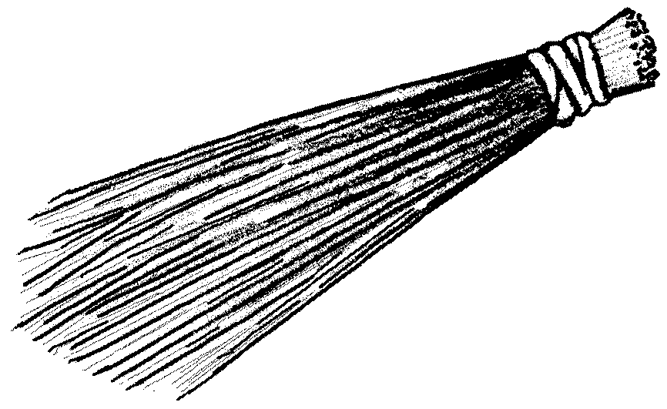This is a ___________________________.

1. Is this a flower?

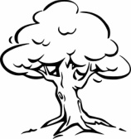_________________________________________.

1. 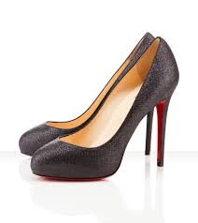Are these uniforms?

**___________________________________.**

**EXERCISE**

**Fill in the missing letters**

1. med_cin_
2. bl_ck
3. un_for_
4. f_ag
5. ba_ge

**Write the words correctly**

a) dgeba--------------

b) formuni-------------------

c) gfla-----------------------

d) fwloer-----------------

**Ref; primary School curriculum**

**Lesson 2**

**Conjunction………….. and…………..**

Joining sentences using ……..and…….

**Examples:**

I have a book. Sarah has a book.

I have a pencil. Dorah has a book.

I have a book and a pencil. Sarah and Dorah have a book each.

Here is a table.

Here is a desk.

Here is a table and a desk.

**Exercise**

1. She has a doll. She has a bag.
2. We ate fish. We ate posho.
3. They like playing with toys. They like playing with balls.
4. Peter went to school. Paul went to school.
5. He has a book. He has a pen.
6. Peter is my friend. Ruth is my friend.
7. The girls are singing. The boys are singing.
8. Mother is cooking rice. Mother is cooking meat.
9. The ducks are swimming. The fish are swimming.
10. Musa is eating sweets. Ivan is eating sweets.

**Lesson 3**

**Comprehension**

**Practical: Internal excursion**

**Vocabulary**

Multiple, industry, fuel tanks, Makindye, Mbogo, division, district

**LOCATION OF OUR SCHOOL**

A school is a place where we go to learn. Our school is White Angels Primary School . It is found along Masajja road Makindye division in Wakiso district.

There are small shops near our school. There is a multiple industry which makes plastic things like chairs, cups, basins, pipes and water bottles. There are fuel tanks near the school field. Some of the important places near our school are churches, markets, mosques, hospitals and schools. Christians go to church for prayers on Sunday while Muslims to the mosque for prayers every Friday.

**Questions**

1. What is a school?
2. What is the name of your school?
3. Along which road is your school found?
4. In which division is your school located?
5. List some of the things made from the multiple industry.
6. Write the title of the passage.
7. What is the title of the passage?
8. Draw your children.
9. Name three important places in the passage.
10. ------------------go for prayers on Sunday.

**Lesson 4**

**Guided composition about the location , symbols and benefits of our school**

vocabulary

fire wood White Angels shops churches

marketsMbogo division

navy blue education mosque

My name is Joel. I go to --------------------------------------------Primary School. It is found along ________________ road in Makindye division. Our school uniform is --------------------------------------- and white. There are many important places near our school. These are ______________, churches, hospitals, schools and shops.

The school provides __________________ and jobs to the neighbourhood and the neighbourhood provides water, books, __________________ and food to the school.

**Ref;** Uganda Primary Curriculum

**WEEK 3**

**LESSON 1**

**VOCABULARY**

ball, hall, library, blackboard, whiteboard, desk, table, near, in, cupboard, books, compound,

Teaching Aids: table, chalkboard, library

**Activity**

1. Reading and spelling the words.
2. Reading and drawing pictures.
3. Using the structures correctly.
4. Showing items in the classroom.

**Exercise 1**

1. Circle the correct word and draw

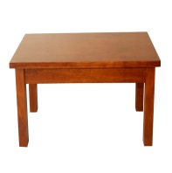Table taelb taebl

1. 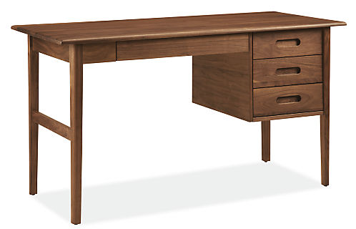Dske dske desk
2. 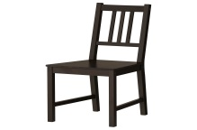Char chiar chair

4. blla ball blal



Teaching Aids: cups, balls, books

**Exercise 2**

Answer correctly

1. What is that?

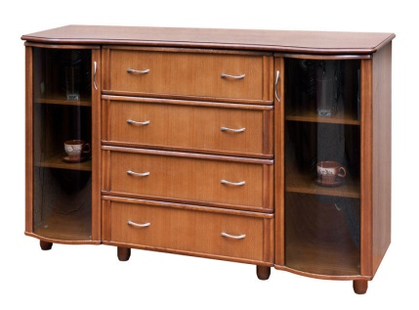

That is a cupboard.

1. What are these**?**



These are balls.

1. Are these flowers?



n

No, they are not.

1. a) Are these tables?

b) How many desks can be seen?

c) How many desks are there?

**Exercise 3**

Where is the:

1. 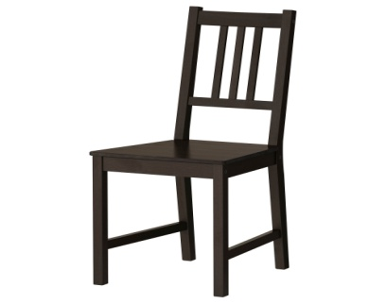ball

_______________________________________

1. book

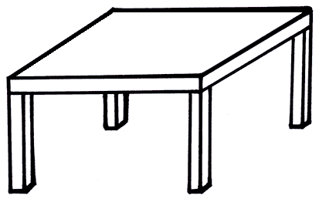

______________________________________

1. 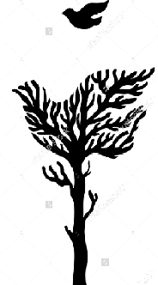bird

______________________________________

1. 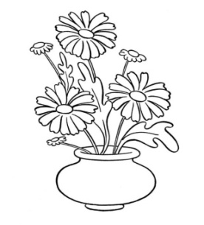flower
2. cupboard

­_______________________________

**Ref:** Uganda Primary Curriculum

Teaching Aids: balls, rubbers, pencils, flowers

Practical: Pupils hold, observe and group 3D objects in the class.

**Lesson 2**

**PLURAL NOUNS**

A noun is a naming word. It is a name of a person or some thing.

**Examples**

* chair - chairs
* pencil -
* rubber -
* chart -
* school -
* table -
* cup -
* spoon -
* flower -
* ball -
* spoon -

**Activities**

1. Give the plurals of these words.
2. Using the nouns in sentences.
3. Change nouns to plural form.

**Exercise 1**

Change these nouns to plural by adding ‘s’

1. boy
2. girl
3. book
4. pen
5. bag
6. ruler
7. plate
8. door
9. window
10. toy
11. cat
12. dog

**Exercise 2**

Change the given words to plural form to fill in the gaps.

1. The _________________are playing . (boy)
2. The _________________are on the table. (book)
3. Are these my ________________ ( pencil)
4. ________________are very beautiful . (flower)
5. Can you arrange the____________________. ( tables)
6. Paul has many _____________. (toy)
7. Jane likes _______________. ( bean)
8. There are new____________. ( cars)
9. Where are my ________________________. (Shoe)
10. _____________ like milk. ( cat )

**Ref: Work book for primary book 2 pg. 9**

**English Aid book 2 pg.**

**Lesson 3**

**Comprehension about symbols of a school**

School symbols are the things which make a school look different from others. These include the school name, school motto, school, school badge, school signpost, school prayer, school mission, school vision and school uniform. Our school motto is Extend Your Horizons. The school motto encourages us to work hard.

We put on the school uniform for identification. Our school uniform is white and navy blue.

**Questions**

1. What are school symbols?
2. Identify any three school symbols?
3. Why does a Primary Two pupil put on a school uniform?
4. Write your school motto?
5. What are the colours of our school uniform?
6. Draw your school uniform.

**Ref: Uganda National Curriculum**

**Practical: study tour, excursion**

**Lesson 4**

Picture composition about the school and the neighbourhood

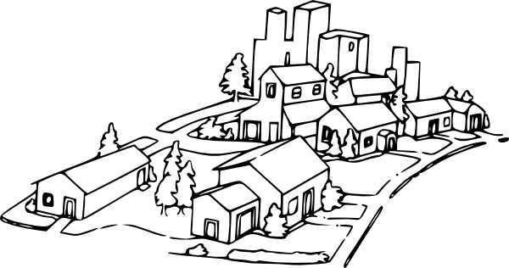

**Questions**

1 .How many people do you see in the picture?

2. Name any three important places near your school?

3. What important places are shown by letters?

A_________________

B_________________

C_________________

D_________________

1. Why do we need a hospital in the community?
2. Where do you go when you want to praise God?

**WEEK 4**

**SUB THEME:**  Causes of problems between the school and neighbourhood.

**Lesson 1**

**Practical: Invite a police officer/ resourceful personnel**

**Vocabulary**

gun, uniform, army, police, policeman, thief, land, fight, blue, white, green, uniformity, colour

Teaching Aids: pictures, uniforms, colours

Activities

1. Reading and spelling the words.
2. Constructing sentences using the words.
3. Using the given structures orally.

**Structure**

Show me a policeman / the men………..

This is a /That is a…/Those are…….

What do you like?

I like ………………..

What don’t you like?

I don’t like……………………

**Exercise**

1. Dictation of words

gun police fight white

uniform thief steal green

policeman land blue policeman

1. **Answer correctly (Children colour the pictures)**

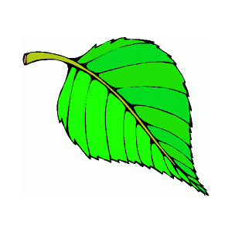What colour is the ……

a) ___________________________

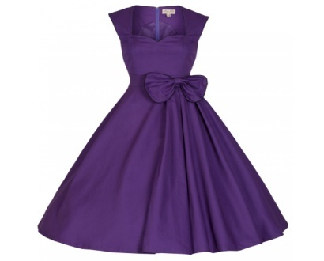

b) ____________________________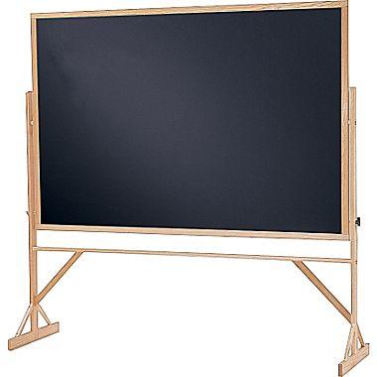

c) _______________________

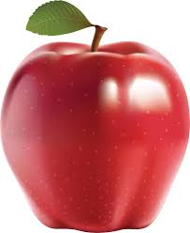

d)

___________________________

Teaching Aids: skipping rope, books, chairs…..

1. What are they doing?

|  |  |  |
| --- | --- | --- |
| a)  Image result for children skipping a rope | Image result for children reading a bookb) | Image result for clipart of children playing footballc) |
|  |  |  |

1. 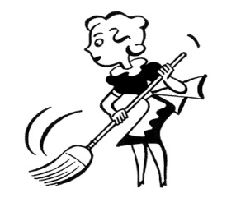What is she/he doing?

a)

___________________________________

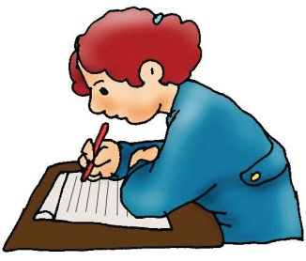

b) _____________________________________

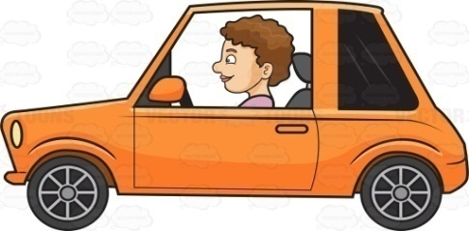c)

_____________________________



d)

______________________________________

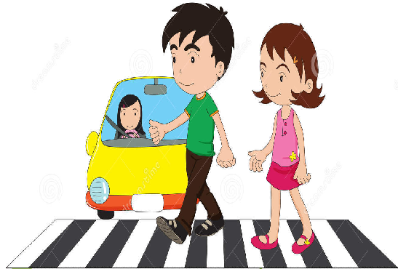

e) ­_________________________________

**Lesson 2**

**Plurals of nouns**

Adding **es** to change nouns to plural.

Words which end with sounds ch, sh, o, x, s, ss change by adding es

**Examples**

1. bus –buses 4.church-churches
2. box-boxes 5.glass-glasses
3. mango-mangoes

**Activities**

1. Giving plurals of nouns ending with ch, sh, s, o, x and ss
2. Using the words in sentences
3. Changing nouns to plural form.

**Exercise**

**Change these nouns to plural form.**

peach- coach- match- rich-

beach- bench- church- watch-

torch- mango- potato- tomato

class- glass- cross- glass-

cross- fox- box- brush-

dish-bush

**Change the given words to plural to complete the sentences.**

1. There are many ___________near our home. (church)
2. Put the ___________in the basket. ( tomato)
3. Mother gave me three ______________. ( mango)
4. The jeweler sold many ________________. ( watch)
5. Emma used four _________________to light the fire . (match)
6. ________________live in the bush .(fox)
7. _________helps us to swim. (coach)
8. ____________give light at night. (torch)
9. I have four ___________in my bag. (peach)
10. May I have six _______ please . (box)

**Ref:**

**Lesson 3**

**A CONVERSATION**

**Lule:** Hello Jesse.

**Jesse:**  Hello Lule.

**Lule:** You did not go to school yesterday, what happened?

**Jesse**  Some bad people damaged our school property.

**Lule:** What things were damaged at your school?

**Jesse:** They broke our fence and stole our books and computers.

**Lule:**

Sorry about that, the police will arrest the thieves.

**Questions**

1. How many people are in the conversation?

2. Who spoke first?

3. Who did not go to school?

4. What bad people broke into Jesse’s school?

5. Draw and name people who keep peace?

6 Write a sentence using these words.

a, policemen b, arresting

**Lesson 4**

**Composition**

Re- arrange these sentences to make a good story

**A**

1. He dresses himself.
2. My father wakes up in the morning.
3. He has his breakfast.
4. Then he goes to work.
5. He drops the children to school.

**a)_____________________________________________________________________**

**b)_____________________________________________________________________**

**c)_____________________________________________________________________**

**d)_____________________________________________________________________**

**e)_____________________________________________________________________**

**B**

1. Then we go to our class.
2. Our teacher teaches us.
3. Ali rings the bell.
4. We go to school.
5. We have an assembly and we pray.

a)_____________________________________________________________________

b)_____________________________________________________________________

c)_____________________________________________________________________

d)_____________________________________________________________________

e)_____________________________________________________________________

**C**

She showed her doll to all her friends.

Mother bought a doll for her.

Her friends were happy to see the doll.

It was Teddy’s birthday.

Teddy was very excited to get the doll.

a)_____________________________________________________________________

b)_____________________________________________________________________

c)_____________________________________________________________________

d)_____________________________________________________________________

e)_____________________________________________________________________

**Ref: Uganda Primary Curriculum (page 15)**

**WEEK 5**

***REVISION AND MID TERM EXAMINATIONS***

**WEEK 6**

**THEME: OUR HOME AND COMMUNITY**

**Practical: role playing**

**SUB THEME: Relationship among family members**

**Teaching Aids: flash cards, pictures…….**

**Lesson 1**

Vocabulary

grandmother grandfather father mother sister brother son daughter cousin niece nephew aunt one two three four five uncle relative related relationship

**Activities**

1. Reading and spelling the vocabulary.
2. Constructing sentences using the vocabulary.
3. Using the structures correctly.

Show me your ………………

This is my ……………………

She / he is my …………….

These / those are my…..

They are my/our /their…….

How many brothers have you got?

I have got three/four brothers……

**Exercise**

**Arrange /write the words correctly**

grnadthermo-_____________

nucel-_____________

tanu-____________

daghteru-___________

**Fill in the missing word correctly**

The sister to your mother is your________________________________

The father to your father is your _______________________________

The mother to your father is your _________________________________

The child to your uncle is your ____________________________________

The daughter to your sister is your_________________________________

The son to your brother is your--------------------------------------------------------

**Make small words from the big ones**

1. son ________________ ________________________
2. father _________________ ________________________
3. cousin_______________ _________________________
4. grandmother ____________ _____________________

**Note: Teach their opposites.**

**Ref: Primary school curriculum**

**Lesson 2**

**Conjunction ………….but…………**

Join the following sentences using ………… but………,

**Example**

1. He fell down . He did not cry.

He fell down but he did not cry.

**Exercise**

1. James came late . He was not punished.
2. She was sick . She went to school.
3. Jane cooked a nice meal. It was not enough.
4. He has a car. He can not drive it.
5. John had a pencil. He did not write.
6. We woke up early. We missed the bus.
7. Anna is clever. She does not like writing work.
8. Sarah packed nice juice. She did not drink it.
9. They finished the work in time. Their work was not marked.

**Lesson 3**

**Comprehension about family relationships**

**MY BROTHER**

This is my brother Peter. He likes climbing up the mango tree. He likes the dog and likes the cat. But he does not like the rabbit or the big black goat. He likes playing football and chess. But he does not like swimming because It makes him wet.

He enjoys eating groundnuts, rice and meat. But he does not like biscuits; they are bad for his teeth.

He likes travelling by bus and train, but he does not like flying in an aeroplane.

**Questions**

1. What is the name of the boy in the story?

2. Which activity makes Peter wet?

3. Are biscuits good for the teeth?

4. What is the title of the story?

5. Write the small words in the big words

groundnuts ________________ ________________.

**6 Write the title for the story.**

**Lesson 4**

**Free composition about family relationships**

**Vocabulary**

blood mother related

marriage cousin father

sister niece uncle

aunt four five

grandmother extendednuclear

**TITLE; Our Family**

**Ref: Uganda Primary Curriculum**

**WEEK 7**

**Lesson 1**

Pluralof nouns

Adding ies to change nouns to plural.

Examples

Changing y to i and adding ies

Teaching Aids; flash cards, toy cars, lorries

**Activities**

1. Give plurals to nouns ending with y
2. Using the words in sentences .
3. Changing nouns to plural form.

**Exercise**

Change these nouns to plural form by changing y to i and adding es.

1. lorry-
2. city-
3. family-
4. pony-
5. party-
6. daisy-
7. fairly-
8. fly-
9. puppy-
10. berry-
11. study-

**Exercise**

Changing the given words to plural to complete the sentences

1. Some ________are red when they are ripe. (berry)
2. Three ________were grazing in the field . (pony)
3. David likes to read _______about animals. ( story)
4. There are­­­­­­­­­­­­­­­­­­­­­­­­­­­­­­­­­­------------- on the food. (fly)
5. Young ________________are fed on milk. (puppy)
6. The ___________have new bags . (lady)
7. The ___________are sleeping now. ( baby)
8. She likes going for ________________. ( party)
9. Many ________________came for the party. (family)
10. Kampala and Nairobi are big _________. ( city)

**Ref : Junior English pg. 27**

**Read and write bk. 2 page 28**

**LESSON 2**

Forming plurals of irregular nouns

Teaching Aids: flash cards, sugar, water, salt, juice

**Note: Their spellings change completely.**

**Examples**

man

tooth

goose

**Activities**

1.Giving plurals of irregular nouns.

2.Constructing sentences using the plural of irregular nouns.

**Exercise 1**

Change these irregular nouns to plural.

1. foot
2. child
3. ox
4. woman
5. man
6. louse
7. mouse
8. goose

Note; The following do not change the spelling in both singular and plural.

Sheep, furniture, luggage, deer, water, hair, equipment

**Exercise 2**

**Change the given irregular nouns to plural form to complete the sentences.**

1. The ______________ are playing in the field. (child)
2. ___________ are used for ploughing. ( ox )
3. The __________ are working in the garden . (woman )
4. My ___________ are as white as snow. ( tooth)
5. Jane’s __________ are dirty. (foot)
6. The ____________ ate all the groundnuts. ( mouse)
7. There are two ________ near the house. (man)
8. ________are domestic birds . (goose)
9. The mad woman has ___________ in her hair. (louse)
10. __________provide us with wool. (sheep)

**Ref: Read and write bk 2 pg 29**

**Practical: resourceful personnel**

**Lesson 3**

Comprehension about roles of people in our community.

A community is a group of people living and working together. There are many important people in our community. These are teachers , nurses, doctors, army men, soldiers , drivers, carpenters, cobblers, barbers and shopkeepers.

Teachers teach in a school , doctors and nurses treat and take care of sick people , policemen keep law and order and arrest wrongdoers, cobblers mend shoes , barbers cut peoples’ hair, shopkeepers sell things in a shop, soldiers keep security and carpenters make and repair things made from wood.

**Questions**

1. What is a community?
2. Where do doctors and nurses work?
3. Which group of people arrest wrong doers?
4. What is the work of carpenters?
5. Who teaches children at school?
6. Write down any three important people in the community?
7. Make small words from the big one
8. carpenter ___________ _____________ ________________
9. teacher -------------------- _____________ ______________
10. shopkeeper ___________ _____________ ______________
11. policeman _____________ __________ __ ______________
12. Find words from the story with these sounds: ck, th, ch, sh, air

**Draw a picture of a teacher.**

**Ref: Uganda Primary Curriculum**

Lesson 4

Activity 1

**Sub theme: Cultural practices and values in the community**

**Vocabulary**

walk read write sweep play clean dirty sing wash brush dance comb

run present pray cook eat

**Activities**

Defining a verb and giving examples of verbs .

A verb is a doing word .

Changing the verbs to present simple tense ( everyday tense ) by adding s

Examples

walk - pray- eat- look- weed- write- mop- get- cook- cut- read put-

**Activity**

Reading and spelling words correctly

Identifying more verbs and forming sentences using the verbs.

**Exercise 1**

**Change these verbs to present simple tense**

work - mop- peel- clap-

drink- swim- sing- jump-

clean- kneel- play skip-

dance- laugh- greet-

**Exercise 2**

1. Daddy ___________ on the farm every day . ( work )
2. My aunt ________________ sweet potatoes every day. (cook)
3. John ______ water every afternoon. ( drink)
4. He _________ breakfast at 8:00 O’ clock. ( eat )
5. Sandra __________ to school every morning . ( walk )
6. Ivan ___________ every night. ( pray)
7. Sophia _______ her room every morning. (mop)
8. Joan_________sweetly. (sing)
9. Moses _____________ the compound every weekend. (clean)

**Composition**

**Substitution table**

**Make correct sentences from the table.**

|  |  |  |
| --- | --- | --- |
| A doctor  A teacher  A policeman  A carpenter  A pilot  A barber | makes  keeps  flies  treats  teaches  cuts | peoples’ hair.  furniture.  anaeroplane.  sick people.  children.  law and order. |

**WEEK 8**

**THEME: THE HUMAN BODY AND HEALTH**

**SUBTHEME : Parts of the body and their functions.**

**Practical: role playing, singing; head, shoulders, knees, and toes then, God thought of making man. Washing different body parts, showing how these body parts are used.**

**Lesson 1**

**T\A-Projector, cut outs**

**Vocabulary**

Parts of the body and their plurals

head – heads leg – legs hair – hair nose - noses

tooth - hair - toe-

mouth - knee –

**Make correct sentences from the tables.**

|  |  |  |
| --- | --- | --- |
| I use | my legs  my teeth  my nose  my knees  my tongue | for tasting.  for walking.  for smelling.  for chewing food.  for kneeling. |

**Lesson 2**

**Punctuation**

**Capital letters and full stops**

1. A telling sentence begins with a capital letter.
2. Capital letters are used to begin names of

a) peoplei)public holidays

b) titles of plays -Easter

c) days of the week - Christmas

d) places -Good Friday

e) titles of films -Labor day

f) months of the year -Heroes day

g) titles of books

h) titles of poems

**Examples**

1. It is a rainy day.
2. Today is Tuesday.
3. Joy went to Jinja yesterday.

**FULL STOPS**

A full stop is a dot put at the end of a telling sentences.

**Examples**

1. I am seven years old.
2. Our school is found along Mbogo road.

**Exercise 1**

Pick out words which should begin with capital letters.

train nurse kampala Friday christmas

flowertuesday peter annetkibuli

bananajane tree mondayfred

**Exercise 2**

**Punctuate these sentences correctly**

1. i have two brothers
2. he must work very hard
3. we went to gulu last week
4. aunt nalule is a nurse
5. the book I read is Cinderella
6. mary and pam are sisters
7. suzan lives in mengo
8. dan will go to London in june
9. we go swimming every thursday
10. i live in kibuli

**REF : Junior English bk 3 page 23**

**Stdengbk 2 pg 11-12**

**Basic eng bk2 and 3 pg 52**

**Lesson 3**

**Comprehension about parts of the body and their functions.**

**PARTS OF THE BODY**

My body has many different parts, namely; ears, eyes, nose, legs, toes, head, tongue, hands and many others. These body parts have various functions ,for example, the tongue is used for tasting, the eyes are for seeing, the nose is for smelling, the ears are for hearing, the legs are for walking, the hands for writing and holding. The knees are used for kneeling.

We care for these body parts through different ways like, brushing the teeth , bathing, cutting finger nails short, combing the hair, cleaning the ears and the nose and scrubbing the feet. It is important to keep our bodies clean.

Questions

1. Write the title of the passage.
2. What is the passage about?
3. Give any four body parts mentioned in the passage.
4. Which body part is used for kneeling down?
5. How can you keep your hair clean?
6. Draw and name these parts of the body. (head, shoulder, chest, eye)

**LESSON 4**

**Free composition about parts of the body**

Guiding words:

tasting hearing mouth ears

feeling seeing teeth legs

skin smelling nose tongue

body bathing eyes clean

brushing soap towel toothbrush

**WEEK 9**

**SUB THEME : SANITATION**

**LESSON 1**

**PRESENT CONTINUOUS TENSE**

Adding ingto verbs

Examples

throw- throwing

brush- brushing

touch- touching

**Activities**

Defining a verb.

Changing verbs to present continuous tense.

Constructing sentences using the verbs.

**Exercise 1**

**Change these verbs to present continuous tense**

1. sit
2. sing
3. mop
4. wash
5. fall
6. go
7. look
8. milk
9. skip
10. fetch
11. drop
12. watch
13. clap
14. read
15. walk
16. cut
17. get

Some verbs ending with (e) change to present continuous tense by dropping the (e ) and adding ing.

give-giving move-

drive- care-

hide- bake-

make- fake-

have- arrive

take- prepare-

wave- write-

dance-

Some verbs that end with a consonant change to present continuous tense by doubling the last letter.

mop, swim, clap, get, sit, cut, stop, skip,

**Exercise 2**

**Use the words** in the brackets to complete the sentences correctly.

1. The children are ___________ their books. ( read )
2. Mother is ____________ some food for me . ( cook)
3. The cat is ____________ milk now. ( drink)
4. James is ______________ the floor now. 9 sweep)
5. Tom is __________ his head now. ( touch )
6. The birds are ________ over the house. ( fly)
7. The children are __________ with a rope. ( play)
8. We are _____a football match. ( watch )
9. Sarah is ________________ her clothes . (wash)
10. I am _________________ a story book. (read)

**Ref : Junior English Bk 2**

**LESSON 2**

**THE QUESTION MARK (?)**

Questions are used at the end of question sentences.

What, how, why, which and where are used to ask questions.

A question begins with a capital letter and ends with a question mark.

**Activities**

Mentioning some of the words used to ask questions .

Constructing questions using the words.

**Exercise 1**

Write any five questions using the these words . What, where,when ,who,how why.

a)_______________________________________________________________

b)_______________________________________________________________

c)________________________________________________________________

d)________________________________________________________________

e) ______________________________________________________________

**Exercise 2**

**Punctuate these sentences correctly**

1. when will the doctor come.
2. which book are you reading
3. how old are you
4. where do you live
5. is the teacher at school
6. what time did you go to bed
7. what is your name

**Lesson 3**

**Teaching Aids: cut outs, brooms, rags, buckets, brushes**

**COMPREHENSION ABOUT SANITATION**

**SANITATION**

Sanitation is the general cleanliness of a place . We keep places like toilets, kitchens, bedrooms, sitting rooms, compounds, fields, and stores clean by mopping, sweeping, dusting, scrubbing, collecting rubbish and removing cob webs.

Some of the things we use when keeping clean are soap, rags, mops, scrubbing brushes , hoes , rake , pangas, dusters, brooms, slashers, basins and buckets.

We need to keep the environment clean, to prevent bad smell, malaria ,snake bites and control the spread of diseases like cholera**,** diarrhoeaand dysentery.

**Questions**

1. What is sanitation?
2. Mention any two places we keep clean.

a)_____________________________ b)____________________________

1. Write the title of the passage’
2. Why should we keep the environment clean?
3. Draw and name any three things used when keeping places clean.

**LESSON 4**

**COMPOSITION ABOUT SANITATION**

Make any five meaningful sentences from the table below.

|  |  |  |
| --- | --- | --- |
| A rake  A panga  A hoe  A broom  A rag | **is used for** | mopping the house  sweeping the bedroom  cutting long grass  collecting rubbish  weeding the compound |

1.___________________________________________________________________

2.____________________________________________________________________

**WEEK 10**

**REVISION AND END OF TERM EXAMINATIONS**

**Week 11**

**T/A :flash cards**

**Lesson 1**

Changing verbs to present simple tense by adding es’

We add es to verbs which end with ch, sh, ss , s , o , x to change them to present simple tense .

**Examples**

brush – brushes

go- goes

do-does

teach- teaches

**Activities**

Identifying more verbs which change to present simple tense by adding ‘es’

spelling the verbs changed to present simple tense.

**Exercise**

Change these verbs to present simple tense

1. hatch
2. hatch
3. dress
4. touch
5. catch
6. fish 11. brush
7. fetch 12. scratch
8. pass 13. slash
9. press 14.go
10. wash 15. do

**Activity**

**Change the sentences with the correct form of the words in the brackets .**

1. Mother __________my uniform every day.
2. Jane ______her homework every evening. ( do )
3. Denis _________ to town on foot every Sunday . ( go)
4. The cat ________ a mouse everyday. (catch)
5. Elizabeth __________ her teeth after every meal. ( brush)
6. Our teacher _______________ us a new song every Thursday. (teach)
7. Jesus __________ us every day. ( bless)
8. Father __________ television every Saturday. ( watch)
9. The maid _________ water from the well. ( fetch)
10. Our body _______________ herself everyday.

**Ref : Mk. Bk 2 pp. 28-29**

**LESSON 2**

**USE OF ……………….because…………**

**Examples**

1. Bob did not go to school. He was sick.

**Bob did not go to school because he was sick.**

1. Joseph passed the examination. He revised his books.

**Joseph passed the examination because he revised his books.**

**Join these sentences correctly using ……….because…………**

1. The little boy fell down. He was running.
2. Moses did not go out to play. He was very tired .
3. The teacher did not mark my work. It was very untidy.
4. Mother did not cook food. There was no firewood.
5. I want to comb my hair. It is untidy.
6. My grandfather cannot see. He is blind.
7. She is sweeping the classroom. It is dirty.

**LESSON 3**

**T/A: eggs, mangoes, milk, beans……**

**THEME : FOOD AND NUTRITION**

**SUB THEME :Classification of food**

**PASSAGE ABOUT FOOD**

**FOOD**

Food is anything we eat or drink that adds value to the body. Examples of food include irish potatoes, meat, sweet potatoes, maize, eggs, mangoes, milk, beans, bananas, peas and chicken. We eat food to be healthy, to be strong , to be happy, for hospitality and to satisfy hunger. Places where we can get food are the market, shop, rivers, lakes and oceans.

There are three food values. These are proteins, carbohydrates and vitamins. Foods rich in proteins are meat, chicken, beans, peas, groundnuts, pork, beef, eggs, mutton and milk. Foods rich in carbohydrates include cassava flour, milk, eggs, Irish potatoes, sweet potatoes, cassava, millet and milk. Foods rich in vitamins are mangoes, pineapples, jackfruit, apples, pawpaws, cabbages, oranges, passion fruit ,lemon, dodo, spinach, guavas and avocado. Milk and eggs have all the food values.

**QUESTIONS**

1. Write the title of the passage.
2. According to the passage,what is food?
3. Mention any four examples of food in the passage.
4. Give any one reason why people eat food.
5. __________ and_________ have all the food values.
6. Draw, colour and name three examples of food.

**LESSON 4**

**PICTURE COMPOSITION ABOUT FOOD**

Questions

1. Name the two friends in the picture.

--------------------------- --------------------

1. How many banana plants are in the garden?

-----------------------------------------------------------------

1. What is Gift holding?

--------------------------------------------------------------------

1. Where are the two friends in the picture?

---------------------------------------------------------------------

1. Who is pulling down the banana plant?

---------------------------------------------------------------------------

1. Write three small words from the word plants.

-------------------- ----------------------- ---------------------------

**WEEK 12**

**LESSON 1**

Vocabulary

fat thin well happy sad small pain weak strong dull

Teaching Aids: flash cards, projector

**Activities**

1. Defining adjectives
2. Giving examples of adjectives.
3. Constructing sentences using the adjectives.

An adjective is a word that describes / talks more about a noun.

**Examples of adjectives**

fat thin ugly beautifulbig sad happy good deep sad dirty clean small

**Exercise 1**

**Write out the adjective in the sentences.**

1. The beautiful girls have gone to swim._______________
2. The teacher does not like noisy children. ___________________
3. I swam in the shallow pool.________________
4. Diana has a heavy bag.______________
5. Peter’s pencil is blunt. __________
6. We had a busy day. __________________

**Lesson 2**

Opposites of adjectives

Examples:

big-small hot-___________

fat-thinquick-___________

heavy-light black-__________

Match correctly

deep clean

sad shallow

dirty happy

fast bad

good slow

**LESSON 3**

**COMPOSITION ABOUT A BALANCED DIET**

David: Hello, Frank.

Frank :Hello,David.

David : What are you eating for lunch?

Frank : I am eating rice , beans and meat.

David : Oh, that’s a nice meal but its missing vitamins to be a balanced meal.

Frank: Oh yes , we did not find any fruits and vegetables in the market.

David: Here you are , you can have an orange to add to your meal.

Frank : Thank you, David. I can now make some juice.

**QUESTIONS**

1. Write the title of the conversation.
2. What is the title of the dialogue?
3. How many people are talking?
4. Who spoke first?
5. What is Frank eating for lunch?
6. Where did Frank get the food from?
7. Who spoke last?

**Ref : Primary School Curriculum for p.2 page 24**

**LESSON 4**

**T/A: cut outs,**

**GUIDED COMPOSITION**

Choose a word to fill in the gaps to complete the passage

Strong, balanced, potatoes, food, weight, protective, death, fruits,

___________ is anything we eat or drink that adds value to the body. Food is classified into three groups namely energy giving foods , body building foods and protective foods.

Among the energy giving foods are cassava, rice, maize, and _____________________.Body building foods include vegetables, and ________________. A meal with all the food values is a ______________ diet.

It is important to have a balanced diet in order to be healthy, _________________ and to grow well.

The effects of poor feeding are blindness and __________, the signs of poor feeding are; a swollen body, loss of ___________ and general body weakness.

**LOCATION OF OUR SCHOOL**

A school is a place where we go to learn. Our school is White Angels Primary School. It is found along Masajja road, Makindye division in Wakiso district.

There are small shops near our school. There is a multiple industry which makes plastic things like chairs, cups, basins, pipes and water bottles. There are fuel tanks near the school field. Some of the important places near our school are churches, markets, mosques, hospitals and schools. Christians go to church for prayers on Sunday while moslems to the mosque for prayers every Friday.

**SANITATION**

Sanitation is the general cleanliness of a place . We keep places like toilets, kitchens, bedrooms, sitting rooms, compounds, fields, and stores clean by mopping, sweeping, dusting, scrubbing, collecting rubbish and removing cob webs.

Some of the things we use when keeping clean are soap, rags, mops, scrubbing brushes , hoes , rake , pangas, dusters, brooms, slashers, basins and buckets.

We need to keep the environment clean, to prevent bad smell, malaria ,snake bites and control the spread of diseases like cholera**,** diarrhoeaand dysentery.

**A BALANCED DIET**

**Diana**  : hello Florence

**Florence** : hello

**Diana :**what are you eating for lunch?

**Florence :** I am eating rice , beans and meat.

**Diana** : oh, that’s a nice meal but its missing vitamins to be a balanced meal.

**Florence:**oh yes , we did not find any fruits and vegetables in the market.

**Diana** :Here you are , you can have an orange to add to your meal.

**My brother**

This is my brother Peter. He likes climbing up the mango tree. He likes the dog and likes the cat. But he does not like the rabbit or the big black goat. He likes playing football and chess. But he does not like swimming because It makes him wet.

He enjoys eating groundnuts, rice and meat. But he does not like biscuits; they are bad for his teeth.

He likes travelling by bus and train, but he does not like flying in an aeroplane.

**PARTS OF THE BODY**

My body has many different parts, namely; ears, eyes, nose, legs, toes, head, tongue, hands and many others. These body parts have various functions ,for example, the tongue is used for tasting, the eyes are for seeing, the nose is for smelling, the ears are for hearing, the legs are for walking, the hands for writing and holding. The knees are used for kneeling.

We care for these body parts through different ways like, brushing the teeth , bathing, cutting finger nails short, combing the hair, cleaning the ears and the nose and scrubbing the feet. It is important to keep our bodies clean.

**FOOD**

Food is anything we eat or drink that adds value to the body. Examples of food include irish potatoes, meat, sweet potatoes, maize, eggs, mangoes, milk, beans, bananas, peas and chicken. We eat food to be healthy, to be strong , to be happy, for hospitality and to satisfy hunger. Places where we can get food are the market, shop, rivers, lakes and oceans.

There are three food values. These are proteins, carbohydrates and vitamins. Foods rich in proteins are meat, chicken, beans, peas, groundnuts, pork, beef, eggs, mutton and milk. Foods rich in carbohydrates include cassava flour, milk, eggs, Irish potatoes, sweet potatoes, cassava, millet and milk. Foods rich in vitamins are mangoes, pineapples, jackfruit, apples, pawpaws, cabbages, oranges, passion fruit ,lemon, dodo, spinach, guavas and avocado. Milk and eggs have all the food values.